SPS 2025
Eplan and Rittal future-proof automation
in electrical engineering
Herborn/Monheim, 21 October 2025
AI is in the starting blocks. Expectation is massive. But how can industry seize its opportunities and take automation to the next level with AI? Eplan , Rittal and Rittal Automation Systems will be providing answers at SPS 2025 under the motto “Automation – Do it”. How? Consistently digitalised processes and intelligent interplay of software, hardware, and automation. Electrical engineers can learn specifically what this looks like in practice by visiting the companies’ booth. Highlights include AI use cases, such as the Eplan Copilot and Automated 3D Design, new approaches using the Asset Administration Shell for Product Change Notification (PCN) and the Eplan Platform 2026. Automation and hardware innovations include the new Rittal Automation Systems Wire Handling System and further Rittal Blue e+ chiller developments.

Panel builders and switchgear manufacturers need to constantly develop technologically if they are to future-proof themselves. Complex designing processes need to be simplified and accelerated – and process steps now also need to be made AI-ready. “The massive opportunities that we can see in future with the help of AI are the reason why electrical engineering companies really need to accelerate digitalisation now,” explains Uwe Scharf, Rittal Managing Director Distribution Germany. After all, consistently digital workflows from designing to manufacturing and service are not yet standard with many electrical engineering companies. “Only companies that digitalise their processes correctly will be able to automate more efficiently in future and take advantage of new technologies, such as AI,” Scharf continues. Properly selected, even small-scale digitalisation steps can produce immediate benefits.

AI-ready: a focus on customer benefits
Eplan and Rittal are demonstrating what will be feasible with AI in electrical engineering in future with a series of different engineering use cases – whether the Eplan Copilot, agent concepts, Automated 3D design, and more. Eplan is pursuing a clear goal: “We want to use AI precisely where it supports designers and makes them more efficient in the engineering process. Our aim is to develop tailor-made solutions that take customers’ processes to the next level,” explains Sebastian Seitz, CEO of Eplan. “We are aiming for maximum and lasting benefits. For this reason, we are focussing on generating real added value for our users using AI.”

AI-ready: database needs to be right
First-class data is the foundation of all automation processes and the use of AI. New approaches using the Asset Administration Shell (administrative shell) and the eCLASS standard will be presented and discussed at SPS. Eplan is also creating totally new perspectives for the change management of products with its Product Change Notification (PCN) solutions, which are of interest to both software users and component manufacturers. It will be showcasing live on an actual system how a modification of a component by a manufacturer is displayed directly in Eplan.

Software: new Eplan Platform 2026
Another highlight at SPS will be the new Eplan Platform 2026. It has evolved the company’s entire product range – with an even greater focus on customers and their requirements in the relevant market segment. Its core focus is on significantly reducing complexity. The new software portfolio makes the performance of the Eplan Platform more transparent – with numerous upgrades transforming it into a comprehensive complete solution in the specialist field of application. Different engineering disciplines can now be integrated in greater depth – to create a complete digital twin for machine or plant automation systems.

Automation: Rittal Wire Handling System
Rittal Automation Systems is improving the efficiency and agility of the “Wire Terminal WT” fully automated wire processing machine in conjunction with the “Eplan Smart Wiring” digital assistance system with its new Wire Handling System (WHS). The system, which will be available after SPS, enables wires processed at the wire terminal to be transported directly to remote workstations by means of a compressed air routing system. Eplan Smart Wiring enables even less experienced employees to handle wiring work. Now they simply request the next correct wire from their workstation at the press of a button. This rules out any risk of confusion. A major benefit of this process is that the system enables one wire terminal to serve several projects and workstations simultaneously. Eplan’s high data quality and Rittal Automation Systems solutions are also paving the way for robotic wiring in future.

Hardware: new chiller program and ex enclosure certification
The upgrade to the Blue e+ chiller will also be showcased, delivering efficient machine cooling and climate control of enclosures and server racks. Rittal now provides solutions that comply with the F-Gas Regulation for almost every application – from machinery and battery energy storage power plants to IT. New output classes of from 1.5 to 7 kW, outdoor models and a hybrid IT chiller with free cooling for particularly high energy efficiency form the core of the expansion of the range. There are also innovations with Rittal ex enclosures: boasting UL HazLoc certification, which are now certified for an operating temperature range of from -50 to +180 degrees Celsius. They already have ATEX and IEC Ex certification for the same operating temperature range.

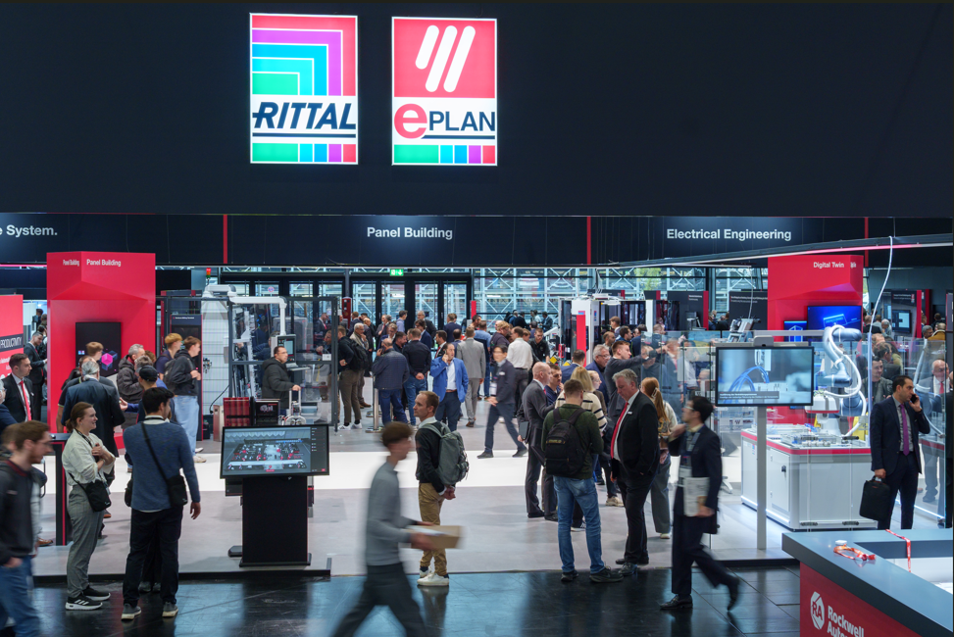 |  | 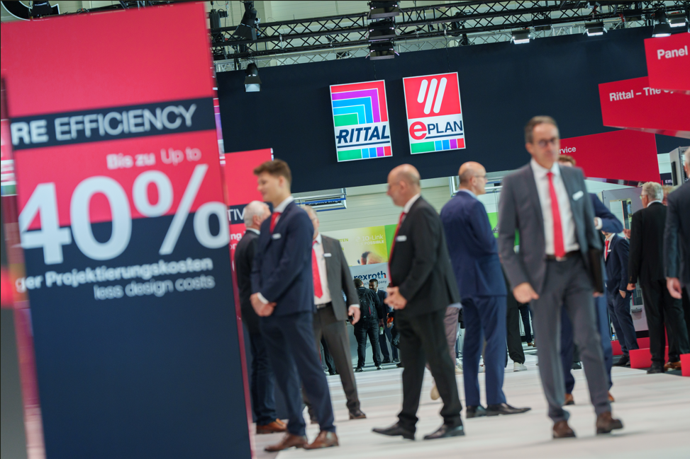
Image 1  Image from the SPS Expo 2024    Rittal Eplan SPS 2024_1.jpg:  Image from the SPS Expo 2024  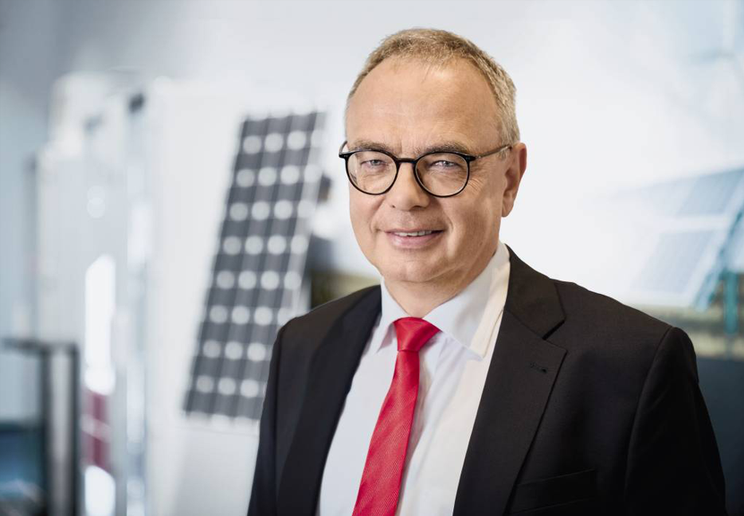 |  | Image 2  Image from the SPS Expo 2024
Image 3  Uwe Scharf, Rittal Managing Director Sales Germany  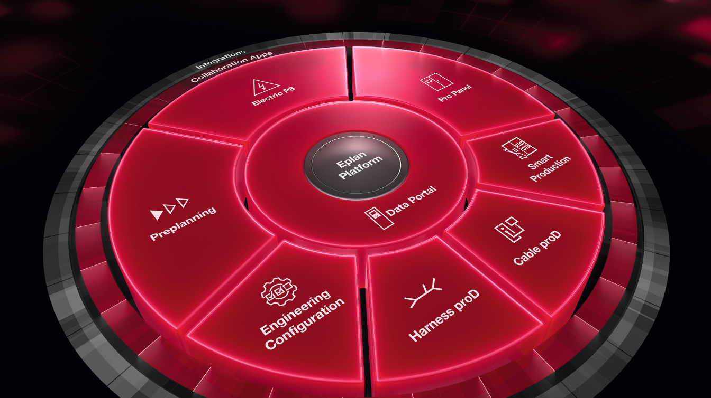  Image 5  Eplan Platform 2026 has evolved the company’s entire product range – with an even greater focus on customers and their requirements in the relevant market segment. |  | Image 4  Sebastian Seitz, Managing Director of Eplan  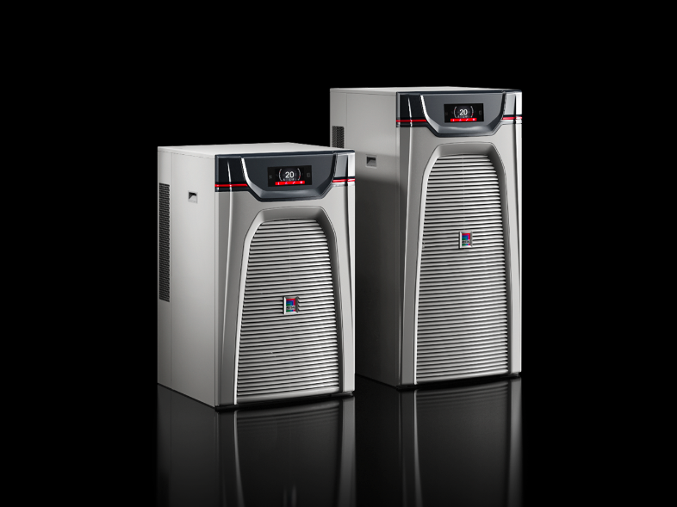  Image 6  Rittal will also be showcasing the upgrade to the Blue e+ chiller, delivering efficient machine cooling and climate control of enclosures and server racks.

May be reproduced free of charge. Please name Rittal GmbH & Co. KG or Eplan GmbH & Co. KG as source.

Rittal

Rittal is a leading global supplier of enclosure systems, automation and infrastructure with its industrial, IT, energy and power, cooling and service units. Rittal products and solutions are used in over 90% of global industries – standardised, customised, and always of the very best quality.
Our approach and methodology: With their combined hardware and software expertise, Rittal, Rittal Software Systems (Eplan and Cideon) and Rittal Automation Systems (RAS, Ehrt, Alfra) optimize, digitize and automate processes along the entire customer value chain, including the IT infrastructure – from panel building and switchgear manufacturing to mechanical engineering, factory operators and the energy sector.
Our delivery promise: Rittal standard products are delivered in Germany within 24 hours, and within 48 hours throughout Europe.
Customer focus
Improving efficiency and increasing productivity through automation and digitalisation is one of the biggest challenges for our customers. This requires in-depth knowledge and expertise, the combination of hardware and software, and cross-sector networking. We are convinced that creating and connecting data rooms is crucial to the success of industrial transformation. And that is exactly our speciality and field of competence.
Eplan and Rittal are driving the development of the digital automation twin, making data accessible and useable in operations as well. Cideon is improving data consistency in the digital product twin context with its CAD/CAM, PDM/PLM and product configuration expertise.
Sustainability
Environmental and climate protection, social commitment and ethical corporate management are a given for Rittal. We take our responsibility for a sustainable future seriously. Our approach to resource management and conservation involves continuous improvement of our own production processes and ensuring that our products have the lowest possible Product Carbon Footprint. Our solutions support our customers in achieving their own climate targets.
Family business and global player
Founded in 1961, Rittal is the largest company in the owner-operated Friedhelm Loh Group. The group operates worldwide, with 13 production sites and 95 international subsidiaries. It has 12,600 employees and posted revenues of 3.1 billion euros in fiscal 2024. In 2023, the Friedhelm Loh Group was presented with the “Best Place to Learn” and “Employer of the Future” awards. In 2025, Rittal was awarded the Top 100 Seal as one of Germany’s most innovative medium-sized companies for the fourth time in a row.
For more information, visit www.rittal.com and www.friedhelm-loh-group.com.

Corporate Communications
Dr. Carola Hilbrand Rittal GmbH & Co. KG
Corporate & Brand Communications Auf dem Stützelberg
Phone: 02772/505-2527 35745 Herborn
hilbrand.c@rittal.de www.rittal.com

Eplan

Eplan provides design, planning and engineering software and service solutions for all aspects of electrical, automation and mechatronic engineering. The company has developed one of the world’s leading design software solutions for machine and panel builders. Eplan is also the ideal partner to simplify and streamline complex and challenging engineering processes.
Both standardised, as well as customer-specific interfaces to ERP and PLM/PDM systems, ensure data consistency across the entire value chain. Working with Eplan means seamless communication across all engineering disciplines. Regardless of whether the company is large or small: It allows customers to use their expertise more efficiently. Worldwide, Eplan serves and supports 73,100 customers. Together with its customers and partners, Eplan strives to continue growing and actively advancing integration and automation in engineering. Within the Eplan Partner Network, open interfaces and seamless integrations are implemented together with partners. “Efficient engineering” is Eplan’s core focus.
Eplan was founded in 1984 and is part of the owner-operated Friedhelm Loh Group. The group operates worldwide, with 13 production sites and 95 international subsidiaries. It has 12,600 employees and posted revenues of 3.1 billion euros in fiscal 2024. In 2023, the Friedhelm Loh Group was presented with the “Best Place to Learn” and “Employer of the Future” awards.
For more information, visit www.eplan-software.com and www.friedhelm-loh-group.com.

Corporate Communications
Birgit Hagelschuer Eplan GmbH & Co. KG
Press- and public relations An der alten Ziegelei 2
Phone: 02173 3964-180 40789 Monheim am Rhein
Hagelschuer.b@eplan.de www.eplan.com

